Ellen Franke

Professor Holley

English 2989 Honors

10 December 2012
Molding a Tradition: The Discourse Communities Affected by Rookwood Pottery

As I perused through the Archives of my Catholic high school, I remember entering a room and immediately locking eyes with a fierce lion in the corner. The lion was painted on a glazed vase outlined with vibrant colors of gold, orange, and red that faded into a deep brown background. I remember a chill running down my spine as I stood in awe of the detail and craftsmanship of this piece of pottery. I continued to look around the room and noticed other pieces similar in texture, but varied in style, shape, and color. Each piece was a breathtaking work of art that captured the viewer’s eye at first glance. I remember a piece of paper laminated and set in the center of the room with a brief history of the pottery. After scanning the page, I realized these pieces were made by a pottery company I had heard of throughout my life, but never knew in detail its purpose or history; I simply knew it was an important part of Cincinnati’s history. Being that the company’s creator owned the Victorian house that eventually became my high school, Saint Ursula Academy, I felt a deep connection to learn more about the cream and brown Tudor style building up on the hills of Mount Adams, outside the valley by the river and the immediate downtown area of the city.
From the time The Rookwood Pottery was established, the creations she produced gave Cincinnatians something to talk about. From the precise sculpting of each piece to the detailed images painted on them, a world-class company for art became known around the globe. The art became a memento for the entire city. As a whole, Rookwood Pottery established a legacy that would be known for many years after her creator had passed. The legacy established brings together many different discourse communities including those of historians, artistic potters, antique collectors, and architects. Historians focus on The Rookwood Pottery as a business, her contributions to Cincinnati, and her journey from open to close and to reinvention in 2006, as explained in Announcing the Rebirth of The Rookwood Pottery Company. In her article Rookwood Art Pottery, Nancy Owen appeals to the minds of artists and potters discussing the techniques used by those employed by the company. Collectors of Rookwood Pottery are memorized by the worth and value of each piece as noted by Wendy Moonan in her article Rookwood, Pottery With A Heritage. Also, Kathy Shorr believes in the architectural value of Rookwood Pottery as described in Sizing Up Cincinnati Underappreciated City Offers Culture, Historic Architecture. Furthermore, from the impact Rookwood Pottery had and still has on these communities, the importance of the business to the city and the entire world is unveiled.
Historically, The Rookwood Pottery Company has a tradition to be proud of. Originally established in 1880 by a woman, Maria Longworth Storer, “Rookwood pottery's production and quality standards exceeded virtually every other American art pottery manufacturer. As a result, Rookwood pottery achieved a greatness that” “made it the largest, longest lasting, and arguably most important of more than one hundred art pottery operations in the United States during the late nineteenth and early twentieth centuries” (Owen, Art Pottery Online). Maria’s wealthy father agreed to fund the business after she fell in love with Japanese ceramic art and hence the company was named after her family estate. With the help of other Cincinnati Women, Maria was able to build up her company staying true to the values of design, detail, and craftsmanship. Although the company expanded in range of style throughout the years of business, it began with influences from Oriental and European cultures leading up to mastering those of the “Victorian, art nouveau, arts and crafts, and art deco” styles (just art pottery). Production of Rookwood Pottery continued until 1940 and the factory eventually closed in the 1960s.
From an artistic aspect, the work done at The Rookwood Pottery Company was second to none. Each piece was created with a specific intention, to mold together a work of art completely unique and unlike any other. The pottery pieces took time to finish and attention to detail was a value close to the hearts of all artists employed. The styles of pottery made as well as the colors that decorated them evolved throughout the business’ years of operation. In regards to the methods and techniques used by The Rookwood Pottery Company, it may be necessary to have previous knowledge of artisan terms and art styles for one to understand the unique build and quality of Rookwood’s impressive products. According to Oxford Art Online,
“The Rookwood Pottery originally produced art wares using underglaze painting in coloured slips on greenware. [Later,] using an earth-tone palette, the artists painted popular subjects on moulded or wheel-thrown objects. […] The early wares used a dark palette of brown earth tones, but after 1890 the colour palette became lighter. After 1900 the firm also produced moulded wares, matt-glazed architectural tiles and porcelain.
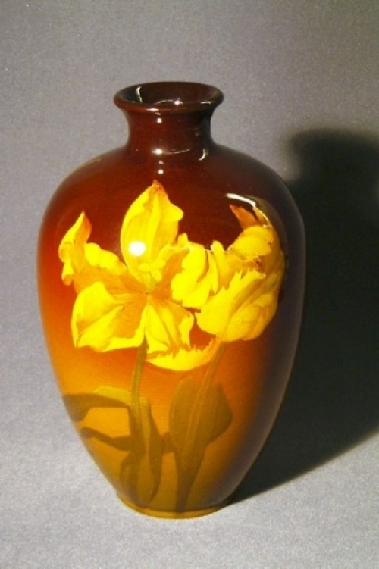
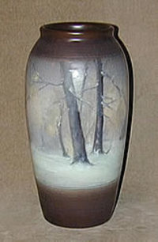
With this information, the process of creation for pottery pieces can be understood simply in words to those outside of an artistic field. However, the time and process it takes to actually create “moulded wares” or an “underglaze painting” cannot be understood without knowledge of what an underglaze painting or a moulded ware actually is. Therefore, many people who are aware of Rookwood Pottery cannot truly appreciate the pieces as individual works of art because the unique craftsmanship behind them is unable to be captured by a simple townsperson. Historians, as mentioned previously could easily state part of Rookwood’s history was the style of underglaze painting, but would not truly be fully interested in what that entails in a deeper sense.
Conversely, men and woman who are artists and potters by profession may have a different opinion on Rookwood Pottery and her inner components. Although naturally talented, even the artists employed by Rookwood Pottery needed to receive extensive training. Although most artists began training as easel painters at either Cincinnati Art Museum or the Cincinnati Art Academy, company management still had to judge an artist’s potential before confirming their employment. This was considered essential “since Rookwood art pottery featured the difficult technique of underglaze decoration, painted before the wares were fired” (Owen). Moreover, “to maintain and enhance the skills of senior decorators it was thought ‘in the Pottery's artistic interest’ to send some of them to Europe, often Paris, for additional training” (Owen). Therefore, unlike the common folk who cannot comprehend the dedication and skill necessary to make just one piece of pottery, professional potters today can look back at the styles used by Rookwood and genuinely value the talent of its employees.
Still, there are others who place a high value on Rookwood Pottery, even though their value is in regard to the Rookwood Pottery name and the pottery’s cash value rather than the perfection of quality. These are the antique collectors who believe in purchasing distinguished relics from the past in order to keep traditions alive that may have faded from their prime. Wendy Moonan, a reporter from The New York Times tells the story of one particular family and how they grew into collecting Rookwood Pottery.
“Mrs. Gordon grew up in Cincinnati but was not keen about Rookwood until 1971. […] In 1971 the Gordons went to Cincinnati to help Mrs. Gordon's parents clear out their house. ''During the course of this endeavor, my mother-in-law asked several times if we thought we were going to find any Rookwood pottery,'' […] ‘Unfortunately, we found only one insignificant piece.’ But his interest was piqued, and the Gordons went to the Cincinnati Art Museum to view its collection before returning home. They were hooked” (Moonan).
Similar to the Gordons, many other antique collectors have come to love the idea of owning a piece of treasured Rookwood Pottery, and “committed Rookwood collectors often collect nothing else” (Moonan). Economic value for the pottery can range anywhere from a few hundred dollars to many thousands of dollars (Lander). Those mentioned above are willing to pay these prices if it means adding to a collection.
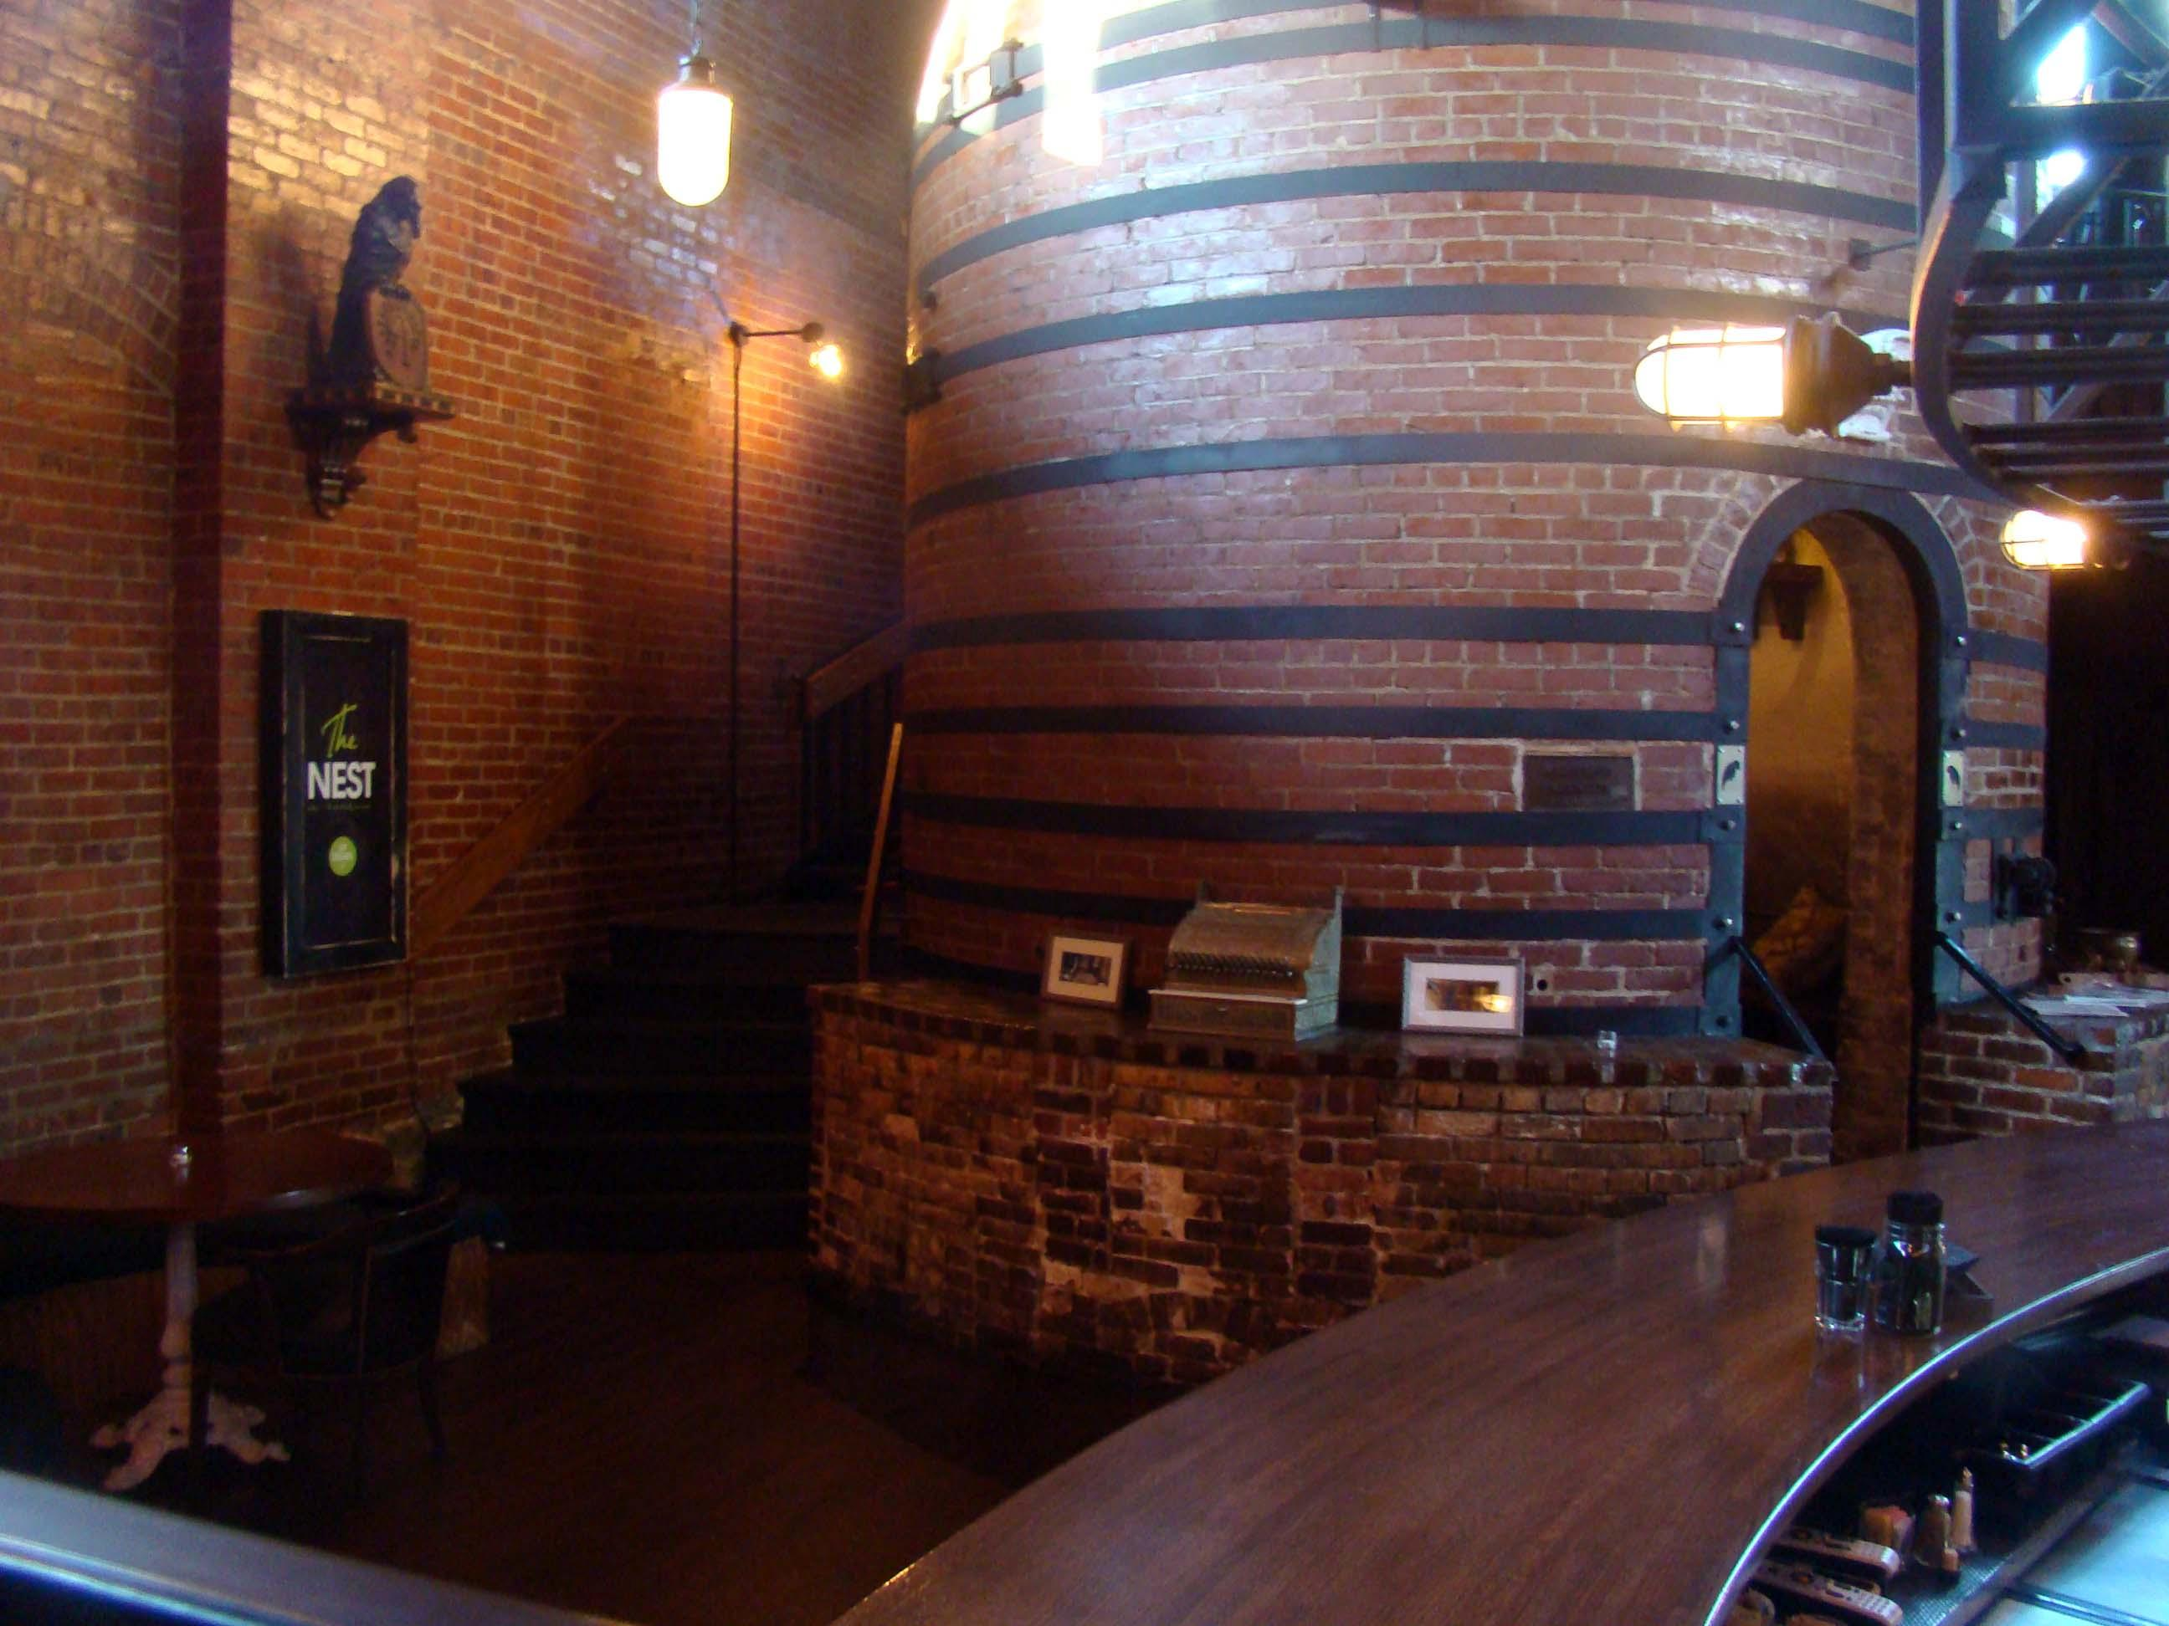
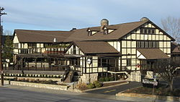
Now, although it may seem as if Rookwood Pottery is solely meaningful to and affects those of potters and antique collectors alike, the company has established itself as an integral part of the greater Cincinnati area and beyond. For example “Rookwood Pottery can be found in grand homes, hotels, and public spaces throughout North America including Union Terminal in Cincinnati, the Mayo Clinic, Rochester and Grand Central Station, New York City” (Anonymous). Specifically, “The Palm Court restaurant/ bar in the Hilton Cincinnati Netherland Plaza hotel has Baroque- style murals, Brazilian rosewood panels, and an immense fountain made of Cincinnati's world-famous Rookwood pottery” (Shorr). In addition to buildings with engravings of Rookwood Pottery, the building home to the company itself makes a statement. “The1892 Tudor-style former factory for Rookwood Pottery [has both an exterior and interior that stand out from an architectural standpoint and is one of the reasons it is referred to as a historically significant building.] Rookwood Pottery closed in 1967, and the building is now a restaurant where diners eat inside enormous beehive-shaped kilns” (Shorr). The
transformation of the Rookwood factory alone connects multiple discourses. Architects can admire the outside of the building for the distinct wooden beams that patch together to create the model Tudor style while socialites can hike up to the hills surrounding the city for a night out and historians can tour around to see what is let of the original work place. Along with the transformation of The Rookwood Pottery factory into The Rookwood Bar and Restaurant, is the renovation of the company into Over-the-Rhine in downtown Cincinnati. With the intent to
“begin to design, engineer, manufacture, and produce new goods, in the established traditions […] The Rookwood Pottery Company product offering includes commercial and architectural products, including ceramic tile, as well as art pottery that adhere to century-old traditions of the original Rookwood Pottery Company” (PR Newswire).
CEO Christopher Rose has brought back to life a brand that captured the hearts of many around the globe.
As a whole, Maria Longworth Storer brought the craft of pottery to a level unattainable by any other company yet to date. Although confronted with challenges along the way, the support of her family and fellow Cincinnati women allowed for the continuing of a tradition that will not fade; a tradition that connects many people together for different reasons. Whether it be to learn the company history, the process of creation, to admire the detailed paintings, or analyze the structure in which her pottery was built, The Rookwood Pottery began in 1880 and has continued to capture the eyes and hearts of those who lay eyes on her.

Works Cited
"Announcing the Rebirth of the Rookwood Pottery Company." PR Newswire: 0. Jul 10
2006. ABI/INFORM Complete. Web. 10 Dec. 2012.
Ellen Paul Denker. "Rookwood Pottery." Grove Art Online. Oxford Art Online. Oxford
University Press. Web. 10 Dec. 2012. <http://www.oxfordartonline.com/subscriber/article/grove/art/T073808>.
"History of Rookwood Pottery from JustArtPottery.com." History of Rookwood Pottery
from JustArtPottery.com. N.p., n.d. Web. 3 Dec. 2012.
Kathy Shorr, Globe C. "Sizing Up Cincinnati Underappreciated City Offers Culture,
Historic Architecture." Boston Globe: 0. Apr 16 2003. National Newspapers Premier. Web. 10 Dec. 2012.
Lander, David. "The Buyable Past: Rookwood Pottery." American Heritage 2005: 14-.
ProQuest Research Library. Web. 10 Dec. 2012.
Moonan, Wendy. "Rookwood, Pottery with A Heritage." New York Times: 0. Feb 20
2004. National Newspapers Premier. Web. 10 Dec. 2012.
Owen, Nancy E. "Rookwood Art Pottery." The Magazine Antiques 2003: 72-81.
ProQuest Research Library. Web. 10 Dec. 2012.
"Rookwood Pottery Company Assumes Auction Division of Cincinnati Art Galleries,
Llc." Antiques & Collecting Magazine 2010: 43-. ProQuest Research Library. Web. 10 Dec. 2012.
Simpson, Richard V. "Rookwood Pottery: A Tradition of Excellence." Antiques &
Collecting Magazine 1999: 32-36+. ProQuest Research Library. Web. 10 Dec. 2012.

