Ellen Franke

Professor Knippling

English 102 Honors

23 January 2012
Bringing the Present into the Past
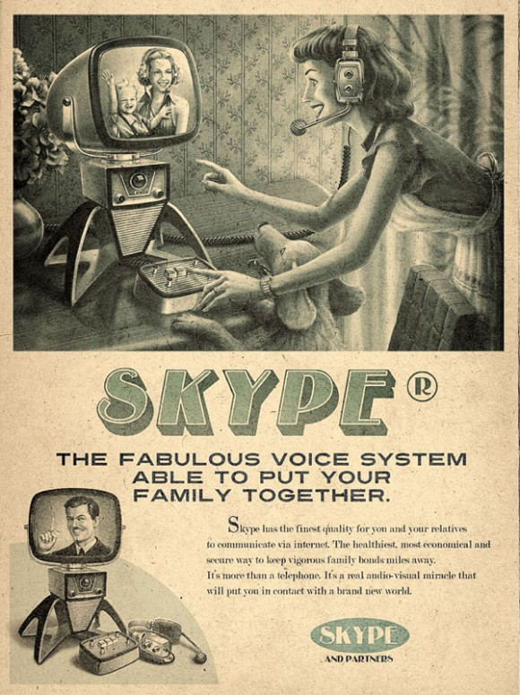

Communication has always been a core element of successful relationships. In earlier ages, communication was challenged by distance, but with present technology one person can connect with another person halfway across the world in a matter of seconds. However, it is fair to say there is still a gap between generations in the realm of technology. For instance, Skype is an application operated by a computer that allows individuals to instant message and video chat with one another and even though it has been available for several years, there are people who would find themselves lost in a conversation about Skype particularly, the older generations. Therefore, one goal of businesses advertising various technological devices is bridging the gap between the older and younger generations living together in society today. This was the exact goal of Moma Propaganda, the creator of more recent vintage technology advertisements. In particular, an advertisement for this technology application known as Skype is designed to target its audience at a different angle.
For this advertisement, rather than depicting the product as a new and futuristic expansion, the creator used a vintage look to promote the application. As a whole, the advertisement is an attempt to bring technology back into the past in order to minimize the technology gap between older and younger generations. Primarily, the ad consists of two images in addition to informational writing. The main image at the top displays a woman who appears to be communicating with another woman via a monitor, keypad, and headset. The second image, in the bottom left hand corner simply displays the complete technology system that is used to operate the Skype application. However, the vintage look is set through the color, design, and language of the advertisement as a whole. First, the ad appears to be printed on old faded paper, with little color used, which brings consumers back to a time when color printing was not common. Aside from the gray scale images and black writing, the only color highlights the product name. This faded shade of blue suggests that technology at the hands of older generations is dull currently, but will increasingly become brighter as they familiarize themselves with the possibilities technology has to offer.
Moreover, the technology devices depicted in the image do not reflect the appearance of technology today. As opposed to the present flat screen monitors, slick keyboards and tiny ear buds, the advertisement displays a bulky monitor, large headset and cord, and control stick with few buttons. These devices are reminiscent of the first box television sets, rabbit ear antennas, and rotary dial telephones. Additionally, the woman operating the system is dressed wearing an apron, with an old-fashioned hairstyle and make-up, giving her the appearance of a 1950’s housewife. Her face expresses her amazement with the ability she has to communicate with others this easily. Furthermore, the smaller image in the corner displays your traditional 1950’s door-to-door salesperson with a winning smile and strong hand as if he were saying, “Be the envy of all your friends.” This iconic character is used as an attempt to bring older generations back into their element to attract them to a new product in a manner they are more familiar with.
Aside from the actual images included in the advertisement, the slogan and description of the technology also contributes to its traditional appearance. The bolded words reading “the fabulous voice system able to put your family together” explain Skype’s purpose very explicitly so that all ages can understand its purpose. Additionally, this slogan targets the idea of family and keeping communication lines open with family members while they are away from home. The idea of the perfect family was stressed in older advertisements much more frequently than it is today, which transports present audiences into the past in order to reestablish the importance of family. However, it is important to notice that the woman in the image is communicating with another woman. If the ad were only trying to appeal to families, one would assume that the person displayed on the monitor would be the typical hardworking husband who was away from home due to business trying to provide for his loving family. Instead, the woman and her child actually pictured on the monitor suggest that Skype is not only for keeping in touch with family members, but friends as well. In addition to the slogan, the more in-depth description of Skype states that it is “more than just a telephone” being a real “audio-visual miracle.” Today, telephones are probably the most common piece of technology used, but in earlier times that was not the case. So to say that Skype is an “audio-visual miracle” appeals to the older generations since it seems to be the first device representing this technology instead of the reality that Skype only enhances that capability that is known by most of the younger generations.
Overall, this advertisement highlights the components of a vintage advertisement in order to bridge the gap between younger and older generations on their familiarity with present technology. For the older generations, this ad attempts to convey the message that technology is well beyond what they grew up with, but it is not complicated to the point where they cannot learn to use it. On the other hand, the younger generation is also targeted because the ad forces them to consider how fortunate they are to have this advanced technology available at their fingertips. With this in mind, it is also fair to say that the technology gap could be minimized if younger generations were to aid the older generations by introducing them to this technology. This could also promote stronger relationships amongst family members if grandchildren taught their grandparents and communicated themselves through this mechanism. With the angle of this advertisement, the creator was trying to “focus on long-range advertising campaigns” [in hopes that] “to build brand loyalty or a relationship with consumers that will be long lasting” (Ramage Bean Johnson 293). As previously stated, the ad promotes Skype technology in a manner that takes the audience into an earlier time as if the technology has existed much longer. By appealing to older audiences creating this vintage look, the technology less intimidating to the older folk because the ad highlights its simplicity, which establishes a relationship. Therefore, all consumers feel connected with a product that enables them to connect with others. Ultimately, the ad combines a vintage look and present technology to catch the eye of all consumers and connect generations to one another.

Works Cited
Moma Propaganda. Advertisement. Www.inventorspot.com. Web. 19 Jan. 2012.
<http://inventorspot.com/articles/social_media_vintage_ads_twitter_facebook_skype_and_youtube_ala_>.
Ramage, John, John Bean, and June Johnson. The Allyn and Bacon Guide to Writing. 5. Boston:
Allyn and Bacon, 2009. Print

